Contents
1. Introduction
2. Summary
3. Keeping Children Safe in Education September 2023
4. Clarity around Allegation vs Low-Level Concern vs Appropriate Conduct
5. Storing and use of Low-Level Concerns and follow-up information
6. Process to follow when a Low-Level Concern is raised
7. Key Reference Document
8. Low Level Concern

1. Introduction
At The Tutorial Foundation, we take safeguarding very seriously. This includes ensuring that adults who work with children do so in a way that is in accordance with the ethos and policies set out by the school, including the Staff Code of Conduct. This policy sets out the detail and processes for staff regarding low-level concerns they may have.
2. Summary
It may be possible that a member of staff acts in a way that does not cause risk to children but is however inappropriate. A member of staff who has a concern about another member of staff should inform the Headteacher about their concern using a Low-Level Record of Concern Form.
3. Keeping Children Safe in Education September 2023
425. As part of their whole school or college approach to safeguarding, schools and colleges should ensure that they promote an open and transparent culture in which all concerns about all adults working in or on behalf of the school or college (including 101 supply teachers, volunteers and contractors) are dealt with promptly and appropriately.
426. Creating a culture in which all concerns about adults are shared responsibly and with the right person, recorded and dealt with appropriately, is critical. If implemented correctly, this should:
• enable schools and colleges to identify inappropriate, problematic or concerning behaviour early
• minimise the risk of abuse, and
• ensure that adults working in or on behalf of the school or college are clear about professional boundaries and act within these boundaries, and in accordance with the ethos and values of the institution.
What is a low-level concern?
427. The term ‘low-level’ concern does not mean that it is insignificant. A low-level concern is any concern – no matter how small, and even if no more than causing a sense of unease or a ‘nagging doubt’ – that an adult working in or on behalf of the school or college may have acted in a way that:
• is inconsistent with the staff code of conduct, including inappropriate conduct outside of work, and
• does not meet the harm threshold or is otherwise not serious enough to consider a referral to the LADO. Examples of such behaviour could include, but are not limited to:
• being over friendly with children
• having favourites
• taking photographs of children on their mobile phone, contrary to school policy
• engaging with a child on a one-to-one basis in a secluded area or behind a closed door, or
• humiliating children.
428. Such behaviour can exist on a wide spectrum, from the inadvertent or thoughtless, or behaviour that may look to be inappropriate, but might not be in specific circumstances, through to that which is ultimately intended to enable abuse.
429. Low-level concerns may arise in several ways and from a number of sources. For example: suspicion; complaint; or disclosure made by a child, parent or other adult within or outside of the organisation; or as a result of vetting checks undertaken.
430. It is crucial that all low-level concerns are shared responsibly with the right person and recorded and dealt with appropriately. Ensuring they are dealt with effectively should 102 also protect those working in or on behalf of schools and colleges from becoming the subject of potential false low-level concerns or misunderstandings.

4. Clarity around Allegation vs Low-Level Concern vs Appropriate Conduct
Allegation
Behaviour which indicates that an adult who works with children has:
- Behaved in a way that has harmed a child, or may have harmed a child
- Possibly committed a criminal offence against or related to a child.
- Behaved towards a child or children in a way that indicates they may pose a rick of harm to children.

Appropriate Conduct
Behaviour which is entirely consistent with the school’s Code of Conduct.
Low Level Concern
Any concern – no matter how small, even if no more than a nagging doubt – that an adult may have acted in a manner which:
- Is not consistent with the school’s Code of Conduct, and/or
- Relates to their conduct outside of work which, even if not linked to an act or omission, has caused a sense of unease about that adult’s suitability to work with children.

5. Storing and use of Low-Level Concerns and follow-up information
LLC forms and follow-up information will be stored securely within the school's safeguarding systems, with access only by the leadership team. This will be stored in accordance with the school’s GDPR and data protection policies.
The staff member(s) reporting the concern must keep the information confidential and not share the concern with others apart from the Head Teacher or those aware in the senior leadership team.
Low-Level Concerns will not be referred to in references unless they have been formalised into more significant concerns resulting in disciplinary or misconduct procedures.
Whenever staff leave The Tutorial Foundation’s any record of low-level concerns which are stored about them will be reviewed as to whether or not that information needs to be kept. Consideration will be given to:
(a) whether some or all of the information contained within any record may have any reasonably likely value in terms of any potential historic employment or abuse claim so as to justify keeping it, in line with normal safeguarding records practice; or
(b) if, on balance, any record is not considered to have any reasonably likely value, still less actionable concern, and ought to be deleted accordingly.

6. Process to follow when a Low-Level Concern is raised

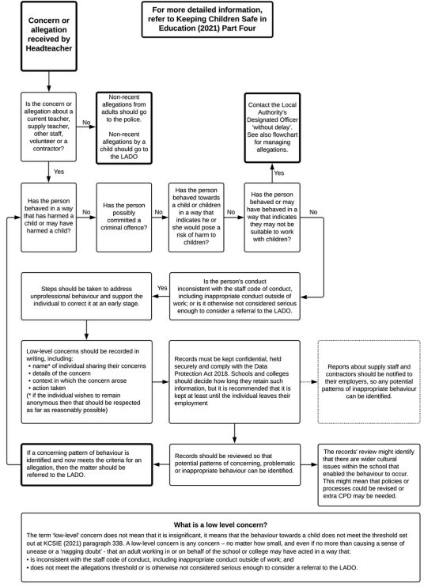
7. Key Reference Document
Read this document for further information about Low-Level Concerns, which is referenced in KCSIE 2022. https://www.farrer.co.uk/globalassets/clients-and-sectors/safeguarding/developing-and-implementing-a-low-level-concerns-policy.pdf (farrer.co.uk)

8. Low Level Concern Form
Low-Level Record of Concern Regarding A Staff Member
Please use this form to share any concern – no matter how small, and even if no more than a ‘nagging doubt’ – that an adult may have acted in a manner which:
· is not consistent with The Tutorial Foundation’s Code of Conduct, and/or;
· relates to their conduct outside of work which, even if not linked to a particular act or omission, has caused a sense of unease about that adult’s suitability to work with children.

Where possible please speak with the Headteacher as soon as possible. It is also helpful to document your concerns, which can be done using this form and then passed to the Head Teacher; or completing a concern on the My Concern App. If the concern is about the Headteacher, please send the form via the School Office, in a sealed envelope to be forwarded to the Chair of The Advisory Board.
This form will be available to staff via:
· The Office
· DSLs
· The Senior Leadership Team

Signed by: Julia Low September 2023
Policy created on: Jan 2022
Review on: September 2024

Please use this form to share any concern – no matter how small, and even if no more than a ‘nagging doubt’ – that an adult may have acted in a manner which:
• is not consistent with The Tutorial Foundation’s Code of Conduct, and/or;
• relates to their conduct outside of work which, even if not linked to a particular act or omission, has caused a sense of unease about that adult’s suitability to work with children.
Where possible please speak with the Head Teacher as soon as possible. It is also helpful to document your concerns, which can be done using this form and then passed to the Head Teacher or via the My Concern App. When completed, please pass this form to the Head Teacher. If the concern is about the Head Teacher, please pass in a sealed envelope to the Office, addressed to the Chair of The Advisory Board.
Allegation
Behaviour which indicates that an adult who works with children has:
- Behaved in a way that has harmed a child, or may have harmed a child
- Possibly committed a criminal offence against or related to a child.
- Behaved towards a child or children in a way that indicates they may pose a rick of harm to children.

Low Level Concern
Any concern – no matter how small, even if no more than a nagging doubt – that an adult may have acted in a manner which:
- Is not consistent with the school’s Code of Conduct, and/or
- Relates to their conduct outside of work which, even if not linked to an act or omission, has caused a sense of unease about that adult’s suitability to work with children.

Appropriate Conduct
Behaviour which is entirely consistent with the school’s Code of Conduct.
Name of adult writing this concern: ………………………………………………………………………………………….
Name of adult whom this concern is about: ……………………………………………………………………………..
Date written: ……………………………
Signature: ………………………………..
Please write your concerns below (continue overleaf) You should provide a concise record – including brief context in which the low-level concern arose, and details which are chronological, and as precise and accurate as possible – of any such concern and relevant incident(s) (and please use a separate sheet if necessary). Consider any contextual information that may be appropriate to know
…………………………………………………………………………………………………………………………………………………………………………………………….
…………………………………………………………………………………………………………………………………………………………………………………………….
……………………………………………………………………………………………………………………………………………………………………………………………. PTO

