The Tutorial Foundation Drugs Policy

The aim of this policy is to acknowledge and clarify the school’s role in drug prevention and education and ensure it is appropriate to pupils’ needs. The policy provides information and guidance about drug education (as well as procedures to respond to any drug-related incident) for pupils, teachers, support-staff and outside agencies or individuals.

The policy aims to ensure that the approach taken on the issue of drugs is a whole-school one and is part of our commitment to and concern for the health and well-being of the whole school community. Teachers will need to be confident and skilled to teach drug education and pupils need to receive up to date, relevant and accurate information as well as support.

This policy aims to make clear procedures for responding to and managing drug-related incidents. Sanctions for incidents will be consistent with the school’s behaviour policy. This policy should also be read in conjunction with the PSHE & Citizenship, Health and Safety, Behaviour & Anti-bullying Policy and SEND policies. This policy applies at all times to the school premises, school transport as well as school visits and trips.

Definition: “Drugs” are taken here to mean those that are legal (such as alcohol, tobacco and solvents);over the counter and prescribed drugs, and illegal drugs such as cannabis, ecstasy, amphetamines, heroin, crack/cocaine, LSD, Novel Psychoactive Substances (NPS) and any other substances covered by the 1971 misuse of drugs act; psychoactive substances act 2016, or that is subject to a temporary class drug order (TCDO 2011). The school prohibits all substances having psychoactive effects on the brain such as depressants, stimulants, cannabinoids, and hallucinogens.

The school believes that the possession and or use of such drugs in school, during the school day or while travelling to/from school is inappropriate. The drugs/substances covered by this policy are not to be bought, sold or otherwise exchanged or brought onto school premises during the school day, or while pupils are on school visits. Individual exceptions may be made for pupils who require prescription medicines where appropriate.

Drug Education: The school provides a planned drug education curriculum through PSHE/Science covering the following:

- Key Stage 3, 11-14 year olds should be taught that abuse of alcohol, solvents, tobacco and other drugs affects health; that the body’s natural defences may be enhanced by immunisation and medicines; and how smoking affects lung structure and gas exchange.
- Key Stage 4, 14-16 year olds should be taught the effects of solvents, tobacco, alcohol and other drugs on body functions.

Other discretionary topics will be delivered through PSHE, and on occasion via outside agencies developing knowledge, understanding, attitudes and social skills that will:
- Enable pupils to make healthy, informed choices
- Promote positive attitudes to healthy lifestyles
- Provide accurate information about substances
- Increase understanding about the implications and consequences of use and misuse
- Widen understanding about related health and social issues
- Enable young people to identify sources of appropriate advice and personal support

Teachers and on occasion, outside agencies will teach drug education. Such agencies will be used in a planned way and their contributions evaluated. Teachers will have access to on-going advice, support and training as part of their own professional development. The school actively cooperates with agencies such as the LA, police, health and drug agencies.

Statutory duty of the school: The Head Teacher takes overall responsibility for the policy and its implementation, for liaison with the Advisory Board, parents/ carers, LA and appropriate outside agencies. The Head Teacher will ensure that all staff dealing with substance issues are adequately supported and trained.

A school cannot knowingly allow its premises to be used for the production, supply or use of any controlled drug (e.g. the preparation of, or smoking of cannabis). If it is ever suspected that substances are being sold on the premises, details regarding those involved will be passed to the police.

Implementation of the policy: In incidents involving substance misuse or supply on the premises/during the school day, and following discussion with the pupil and staff, action will proceed as follows.
The school has adopted the procedures as laid out in Drugs: advice for schools (DFE-00001-2012)

- Any medical emergencies will be dealt with as per Appendix A.
- In cases of substance use/misuse or supply on the premises, during the school day or during school visits etc, the case will be discussed with the young person and a written record taken (see Appendix C); parents/carers will be informed by the Head or Assistant Head Teacher as soon as possible. The support of outside agencies will be sought if appropriate.
- If a young person admits to using or supplying substances off the premises, the appropriate action will be to inform a DSL/member of SLT who will inform the parents/carers.
- While there is no legal obligation to inform the police, they may also be involved at the discretion of the Head teacher in consultation with Advisory Board members and staff who know the young person well.
- The school will consider each incident individually and will employ a range of responses to deal with each incident. Specific cases will be managed as per Appendix B: all staff, pupils, parents/carers should be made aware of this.
- The Advisory Board will be involved in drug-related incidents as they are concerning other matters relating to the school.

APPENDIX A : Medical emergencies involving drugs
APPENDIX B : Non-medical situations involving drugs
APPENDIX C : Record of drug-related situation/specimen record sheet

 | By whom | Date
Policy signed off by | Julia Low | 13.02.2015
Reviewed by | Emma Clyde | 01.12.2023
Next Review By | Julia Low and Advisory Board | 01.12.2024

Appendix A : Medical emergencies involving drugs

The procedures for an emergency apply when a person is at immediate risk of harm. A person who is unconscious, having trouble breathing, seriously confused or disorientated or who has taken any harmful toxic substance, should be responded to as an emergency.

The main responsibility is for the pupil at immediate risk, but you also need to ensure the well- being and safety of others. Put into practice the school’s first-aid procedures. If in any doubt, call medical help.

Always:
- Assess the situation
- If a medical emergency, send for medical help and ambulance

Before assistance arrives
If the person is conscious:
- Ask them what has happened and to identify any drug used
- Collect any drug sample and vomit for medical analysis
- Do not induce vomiting
- Do not chase or over-excite them, keep them under observation, warm and quiet

If the person is unconscious:
- Ensure that they can breathe and place in the recovery position
- Do not move them if a fall is likely to have led to spinal or other serious injury which may not be obvious
- Do not give them anything by mouth
- Do not attempt to make them sit or stand
- Do not leave them unattended or in the care of another pupil
- Notify parents/carers

For needle stick(sharps) injuries:
Encourage wound to bleed. Do not suck. Wash with soap and water. Dry and apply waterproof dressing ensuring full PPE is worn whilst administering first aid
If used/dirty needle seek advice from a doctor – ensure the needle is disposed of correctly unless needed for investigation

When medical help arrives
- Pass on any information available, including vomit and any drug samples
- Complete a medical record form as soon as you have dealt with the emergency.
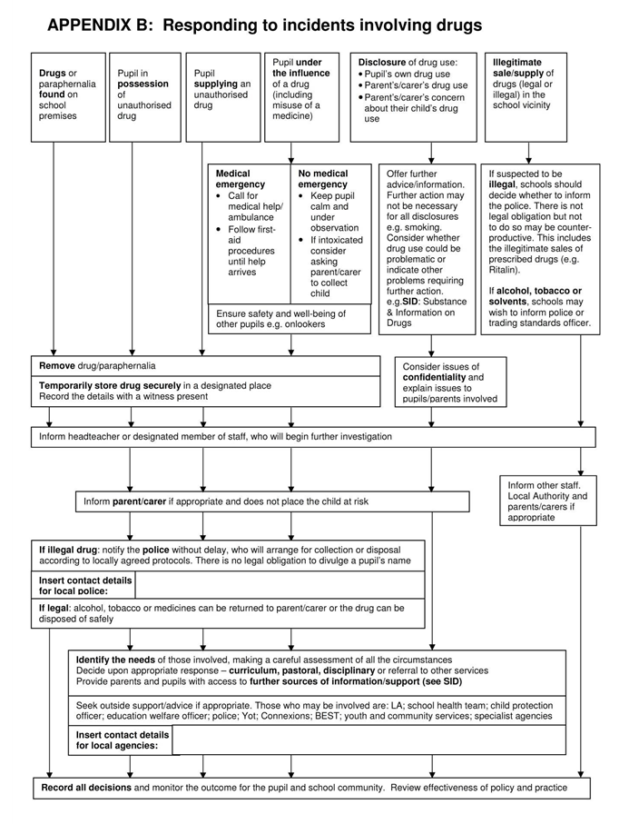
0208 289 1999 - Bromley Change Grown Live

referrals.bromley@cgl.org.uk
(0208) 284 8847/721 2613 Youth Policing/Safer Neighbourhood

Appendix C: Record of incident involving unauthorised drug
- For help and advice, telephone the Youth Policing or Safe Neighbourhood Teams (0208) 284 8847/721 2613
- Complete this form and pass to a DSL or enter incident on MyConcern.

Tick below as appropriate
- Drug or paraphernalia found ON school premises
- Disclosure of drug use/misuse
- Emergency/Intoxication
- Allegation of drug use/misuse
- Pupil in possession of unauthorised drug
- Parent/carer expresses concern
- Pupil supplying unauthorised drug on school
- Other (eg suspected drug use)

Name of pupil : | Year/Group:
Date: | Time of incident:
Age of pupil:  MALE / FEMALE | Date of incident:
Other pupils involved:
Tick box if second or subsequent incident involving same pupil | Report form completed by:
First Aid given? YES NO  First Aid given by: ………………………………… | Ambulance/Doctor called? YES NO  Called by: ……………………… Time: ………

Drug involved (if known)  eg.alcohol/cannabis  Senior staff involved:  Police incident reference number:  Disposal arranged with (police/parents/other?) |  | Drug found/removed? YES/NO  Where found/seized:  Name/signature of witness:
Brief description of incident (including any physical symptoms):

:
Action taken: (eg. sanction/ meeting with parents/ staff informed/ LA/Police consulted)

