Contents
1. Introduction
2. Summary
3. Keeping Children Safe in Education September 2021
4. Clarity around Allegation vs Low-Level Concern vs Appropriate Conduct
5. Storing and use of Low-Level Concerns and follow-up information
6. Process to follow when a Low-Level Concern is raised
7. Key Reference Document
8. Low Level Concern

1. Introduction
At The Tutorial Foundation, we take safeguarding very seriously. This includes ensuring that adults who work with children do so in a way that is in accordance with the ethos and policies set out by the school, including the Staff Code of Conduct. This policy sets out the detail and processes for staff regarding low-level concerns they may have.
2. Summary
It may be possible that a member of staff acts in a way that does not cause risk to children but is however inappropriate. A member of staff who has a concern about another member of staff should inform the Head Teacher about their concern using a Low-Level Record of Concern Form or adding a concern to the My Concern App.
3. Keeping Children Safe in Education September 2021
The following is taken from Keeping Children Safe in Education September 2021.
407. As part of their whole school approach to safeguarding, schools and colleges should ensure that they promote an open and transparent culture in which all concerns about all adults working in or on behalf of the school or college (including supply teachers, volunteers and contractors) are dealt with promptly and appropriately.
408. Creating a culture in which all concerns about adults (including allegations that do not meet the harms threshold (see Part Four - Section one)) are shared responsibly and with the right person, recorded and dealt with appropriately, is critical. If implemented correctly, this should encourage an open and transparent culture; enable schools and colleges to identify concerning, problematic or inappropriate behaviour early; minimise the risk of abuse; and ensure that adults working in or on behalf of the school or college are clear about professional boundaries and act within these boundaries, and in accordance with the ethos and values of the institution.

What is a low-level concern?
409. The term ‘low-level’ concern does not mean that it is insignificant, it means that the behaviour towards a child does not meet the threshold set out at paragraph 338. A low-level concern is any concern – no matter how small, and even if no more than causing a sense of unease or a ‘nagging doubt’ - that an adult working in or on behalf of the school or college may have acted in a way that:
· is inconsistent with the staff code of conduct, including inappropriate conduct outside of work; and
· does not meet the allegations threshold or is otherwise not considered serious enough to consider a referral to the LADO.
410. Examples of such behaviour could include, but are not limited to:
· being over friendly with children;
· having favourites;
· taking photographs of children on their mobile phone;
· engaging with a child on a one-to-one basis in a secluded area or behind a closed door; or,
· using inappropriate sexualised, intimidating or offensive language.

411. Such behaviour can exist on a wide spectrum, from the inadvertent or thoughtless, or behaviour that may look to be inappropriate, but might not be in specific circumstances, through to that which is ultimately intended to enable abuse. 412. It is crucial that any such concerns, including those which do not meet the harm threshold (see Part Four - Section one), are shared responsibly and with the right person, and recorded and dealt with appropriately. Ensuring they are dealt with effectively should also protect those working in or on behalf of schools and colleges from potential false allegations or misunderstandings.
4. Clarity around Allegation vs Low-Level Concern vs Appropriate Conduct
Allegation
Behaviour which indicates that an adult who works with children has:
- Behaved in a way that has harmed a child, or may have harmed a child
- Possibly committed a criminal offence against or related to a child.
- Behaved towards a child or children in a way that indicates they may pose a rick of harm to children.

Appropriate Conduct
Behaviour which is entirely consistent with the school’s Code of Conduct.
Low Level Concern
Any concern – no matter how small, even if no more than a nagging doubt – that an adult may have acted in a manner which:
- Is not consistent with the school’s Code of Conduct, and/or
- Relates to their conduct outside of work which, even if not linked to an act or omission, has caused a sense of unease about that adult’s suitability to work with children.

5. Storing and use of Low-Level Concerns and follow-up information
LLC forms and follow-up information will be stored securely within the school's safeguarding systems, with access only by the leadership team. This will be stored in accordance with the school’s GDPR and data protection policies.
The staff member(s) reporting the concern must keep the information confidential and not share the concern with others apart from the Head Teacher or those aware in the senior leadership team.
Low-Level Concerns will not be referred to in references unless they have been formalised into more significant concerns resulting in disciplinary or misconduct procedures.
Whenever staff leave The Tutorial Foundation’s any record of low-level concerns which are stored about them will be reviewed as to whether or not that information needs to be kept. Consideration will be given to:
(a) whether some or all of the information contained within any record may have any reasonably likely value in terms of any potential historic employment or abuse claim so as to justify keeping it, in line with normal safeguarding records practice; or
(b) if, on balance, any record is not considered to have any reasonably likely value, still less actionable concern, and ought to be deleted accordingly.

6. Process to follow when a Low-Level Concern is raised

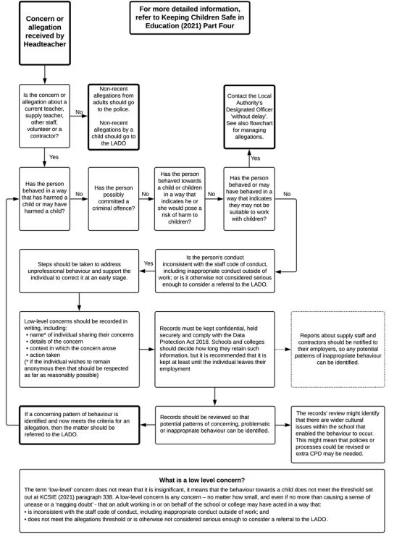

7. Key Reference Document
Read this document for further information about Low-Level Concerns, which is referenced in KCSIE 2021. https://www.farrer.co.uk/globalassets/clients-and-sectors/safeguarding/low-level-concerns-guidance-2020.pdf
8. Low Level Concern Form
Low-Level Record of Concern Regarding A Staff Member
Please use this form to share any concern – no matter how small, and even if no more than a ‘nagging doubt’ – that an adult may have acted in a manner which:
• is not consistent with The Tutorial Foundation’s Code of Conduct, and/or;
• relates to their conduct outside of work which, even if not linked to a particular act or omission, has caused a sense of unease about that adult’s suitability to work with children.

Where possible please speak with the Headteacher as soon as possible. It is also helpful to document your concerns, which can be done using this form and then passed to the Head Teacher; or completing a concern on the My Concern App. If the concern is about the Headteacher, please send the form via the School Office, in a sealed envelope to be forwarded to the Chair of The Advisory Board.
This form will be available to staff via:
· Low Level Concerns - The Tutorial Foundation
· The Office
· DSLs
· The Senior Leadership Team

Signed by: Julia Low Jan 2022
Policy created on: Jan 2022
Review on: Jan 2023

