**Day School Website**

Just to remind you that our website is a source of school information and the latest school news. It can be viewed by the following link

[Day School - The Tutorial Foundation](https://thetutorialfoundation.co.uk/day_school_home/)

Please also sign up to our Twitter account https://twitter.com/tutorial_day.

**Key dates for the diary:**

**Year 11 Mock Exams Week:** 6-9th December

**London Trip:** 10th December

**Christmas Lunch:** Thursday 16th December

**End of Term**: Friday 17th December, 1pm

**Start of Term**: Tuesday 4th January, 11am

Projects are a combination of students’ research, experimentation with a range of mixed-media and tutor direction. Projects to date have included jewellery making, creating a mural for outside space, den building, acrylic flow painting, collage, 3D sculptures from recycled materials, and mosaics.

**Complaints**

If for any reason you wish to make a complaint, kindly complete and return to us the Parents Complaints Form on the website and we will respond as quickly as possible.

***Art at The Tutorial Foundation***

Art sessions with our in-house artist Lou, help our students develop visual self-expression, giving them the chance to explore their own and others’ emotions, develop social and communication skills and self-confidence; whilst exploring their hopes and dreams for the future. All this within a relaxed, quiet, and calm learning environment.

*For Student Safety, please note we are a Nut-Free school!*

Due to some students with serious nut allergies, we are a Nut Free School. Please do not send in nuts or products that contain nuts in packed lunches or snacks.

Please can you inform us if your child has any other medical issues that may require us to administer medication. Please hand any medications to the office in a sealed bag.

**OUR POLICIES**

All of our policies are available for parents and carers to view on our website or by request from our School Office.

**ABSENTEES REMINDER**

If your child is going to be absent for any reason please ensure that we are informed by 10am the same morning, (messages can be left on our answer phone or emails can be sent).

**The Tutorial Foundation Newsletter**



**Issue Dec 2021**

***Cooking At School***

Dear Parents and Carers

We’ve had a busy start to the new school year with all students enjoying our recent Film Festival. Our Year 11’s have enjoyed our National Citizenship Programme which ran over four weeks, we enjoyed meeting our Year 11 Parents & Carers and we’re busy getting ready for the Year 11 Mock Exams.

With the festive season fast approaching we are looking forward to our annual student and staff Christmas Lunch on Thursday 16th December and a special all school trip to Covent Garden.

Due to Staff Training, **students should arrive at 11am on Jan 4th**.

With very best wishes for the festive season,

Julia Low

**A Message from the Headteacher**

Address: 76 Freelands Road

Bromley

Kent BR1 3HY

Tel: 020 8460 0181 option 3

Fax: 020 8290 0117

Email: [sen@thetutorialfoundation.co.uk](mailto:sen@thetutorialfoundation.co.uk)

Web: [www.thetutorialfoundation.co.uk](http://www.thetutorialfoundation.co.uk)

**School Opening Times:**

Monday 9 am-2pm

Tuesday 9 am-2pm

Wednesday 9 am-2pm

Thursday 9 am-2pm

Friday 9 am-2pm

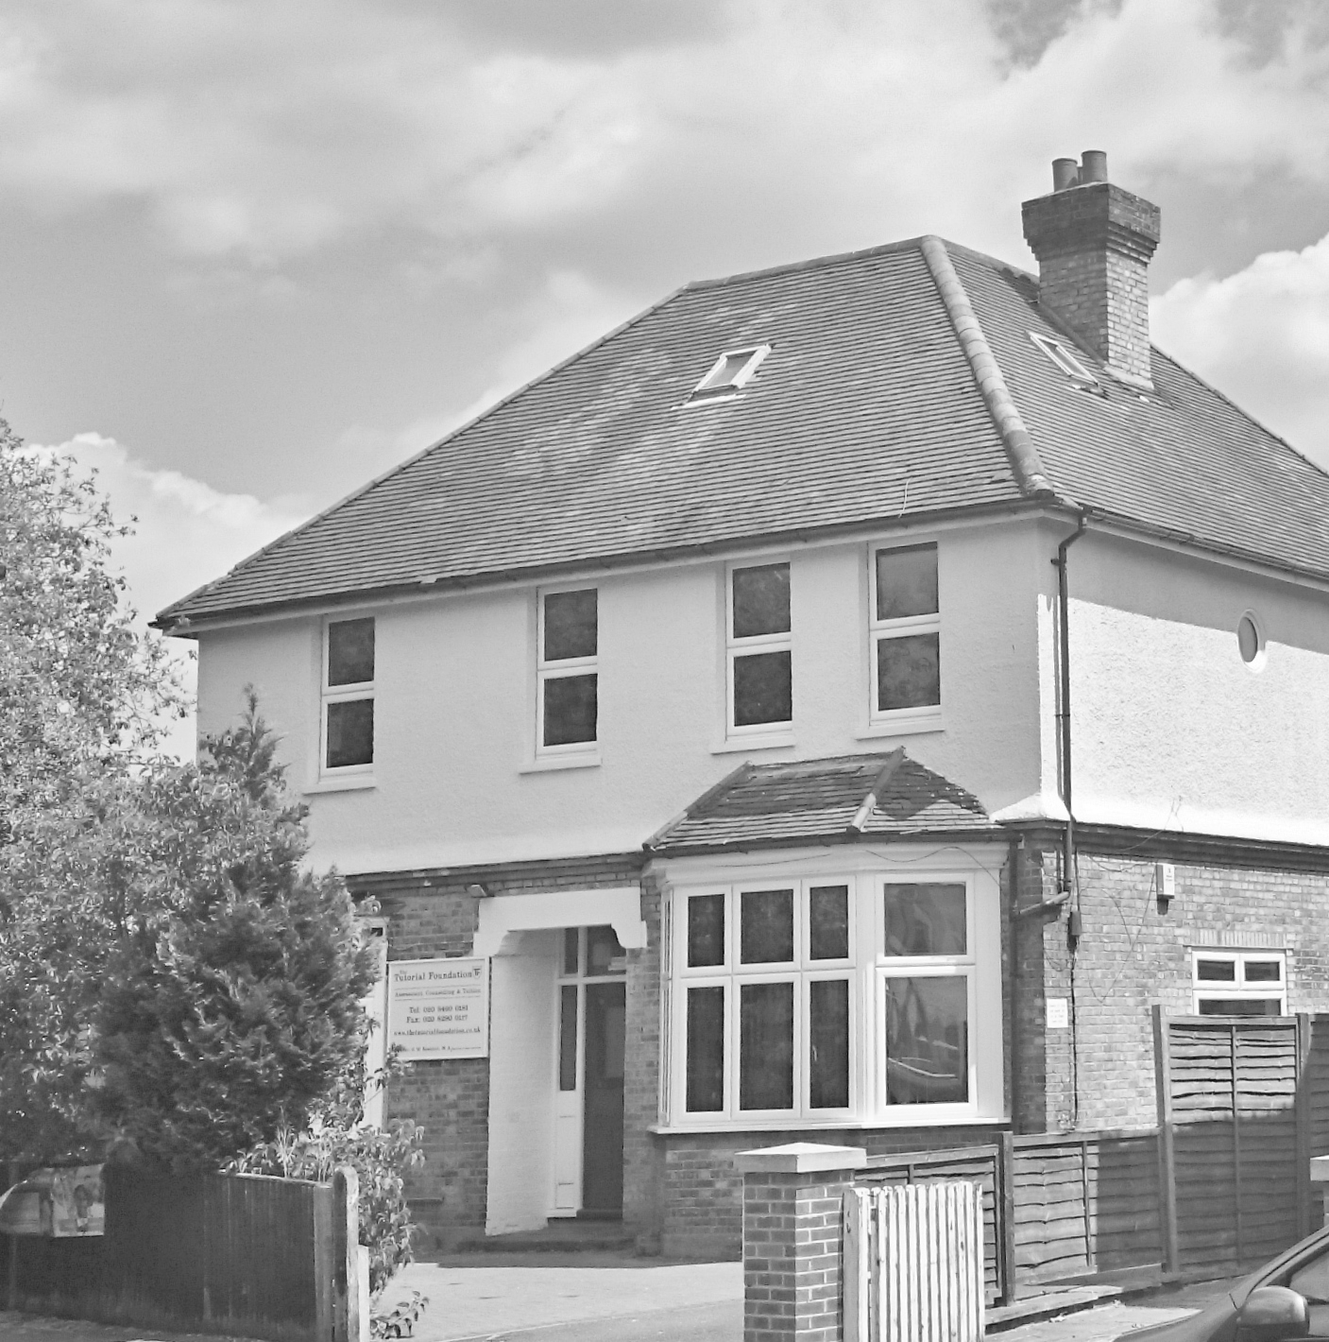

***….Engagement; Challenge; Autonomy and Feedback***

.

Thea, our in-house cookery tutor, has been helping our students prepare and create delicious and nutritious lunches which are enjoyed by staff and students alike.

These have included jerk chicken, homemade burgers, spaghetti bolognaise, Bombay chicken, macaroni cheese, millionaires’ shortcake, chocolate cookies and much more. The students also prepare a healthy salad and vegetables to accompany every meal.

We also provide fruit, cereal bars and sandwiches.

