Coronavirus (COVID-19) Risk assessment

Company name: The Tutorial Foundation Assessment carried out by: Katy Harris

Date of next review: 07/01/22 Date assessment was carried out: 24/11/21
- For the purpose of this risk assessment, the term ‘coronavirus’ to refer to coronavirus disease 2019 (COVID-19).
- The Tutorial Foundation ensures that this risk assessment reflects the local setting and context of the school.
- Staff are consulted with regard to this risk assessment.
- This risk assessment is not exhaustive and is issued to assist in the production of a comprehensive document that covers the particular circumstance of our setting.
For further reference,
- https://www.gov.uk/government/publications/actions-for-schools-during-the-coronavirus-outbreak/guidance-for-full-opening-schools
- https://www.nhs.uk/conditions/coronavirus-covid-19/symptoms/
- https://www.nhs.uk/conditions/coronavirus-covid-19/testing-and-tracing/

What are the hazards? | Who might be harmed and how? | What are you already doing to control the risks? | What further action do you need to take to control the risks? | Who needs to carry out the action? | When is the action needed by? | Done
Onsite Students and Staff being infected with Coronavirus (COVID-19) | Students (mostly classed as vulnerable) & Staff | Lateral Flow Testing staff x 2 per week. If in close contact with a positive case, Lateral Flow Testing daily for 7 days. | Follow Testing Addendum below. | Headteacher/Staff | Weekly/Daily
 |  | All staff and students encouraged to wear masks in communal areas and where they are unable to practise social distancing of at least 2m |  | All Staff/students | Daily
 |  | Insisting on regular handwashing and hand-sanitising of both students and staff including on arrival and departure. | Remind students and staff every day. | All Staff | Daily
 |  | Insisting on students using a tissue or elbow to catch a cough or sneeze. | Remind students and staff every day. | All Staff | Daily
 |  | Encouraging students not to touch mouth, eyes or nose | Remind students and staff every day. | All Staff | Daily
 |  | Anti-bacterial cleaning all surfaces every morning and throughout day. | Weekly update and briefing with cleaners to ensure following cleaning guidelines | Katy/Julia/Cleaner | Daily/weekly
 |  | Maximum of 4 students in a classroom | Person on duty to check guidelines are being followed. Staff/Students to be reminded regularly. | All Staff | Daily
 |  | Maximum of one teacher in a classroom | Person on duty to check guidelines are being followed. Staff to be reminded regularly. | All Staff | Daily
 |  | Students groups assigned to one classroom for all lessons. | Person on duty to check guidelines are being followed. Staff/Students to be reminded regularly. | All Staff | Daily
 |  | Encouraging students to take lunch, break and PE in outdoor space. | Persons on duty to check guidelines are being followed. Staff/Students to be reminded regularly. .; | All Staff | Daily
 |  | Prop doors open & open windows | Person on duty to check guidelines are being followed. Staff to be reminded regularly. | All Staff | Daily
 |  | Reminding students, staff and parents not to attend the setting and get a PCR test if they are displaying any symptoms of Coronavirus. | Communicate to Parents, Carers, Staff and Students | Katy | Fortnightly update
 |  | Posters displayed around the school communicating protective guidelines | Check on displays | Katy | Weekly
Harm to vulnerable students who are not attending school or engaging with remote-learning | Students | Keeping daily register of attendance, following up any absence with phone calls/home contact. | Following absence procedures. | Tertia/Josie | Daily

ADDENDUM: TESTING PROCEDURE & READING THE RESULTS

I attach a couple of photos explaining the sampling procedure and what the test results look like.

It is a simple process with essentially 4 steps, if in doubt see detail below:
- 6 drops of special testing reagent from the bottle supplied into a plastic vial/tube
- take a sample from throat and nose using a swab and mix into the reagent in the vial
- 2 drops from the vial into the S (ample) hole in the plate
- 25 minutes for the result

To ensure that it all goes smoothly it is worth reading the below before you start.

Before you start please “blow your nose” to clear any excess mucus.

1. Squeeze – CAREFULLY. 6 drops of reagent into one of the flexible plastic vials and support upright. (Tip: Hang it on the edge of a cup to support it)
2. Open the sealed packet containing the test plate
3. Take out a fresh swab from one of the sealed packets, leave the packet on the surface so that you can use it to dispose of the swab when finished.
wipe the swab up & down 3 -4 times at back left of mouth (as far back as you can go.!,) … and repeat on the other side. Try not to touch the sides of your mouth. Now insert the swab 2.5cm into your left nostril and swizzle it against the side of the nostril, take out and repeat on the other nostril.
4. Pick up the plastic vial and insert the swab, rotate the swab, and rub it up and down, against the inside of the vial to transfer your sample to the fluid in the vial. As you remove the swab the vial is flexible so squeeze it as you withdraw the swab to wipe off and retain as much of the sample as possible.
5. Push the used swab into its original packet ready to be disposed of. Push the top onto the vial and squeeze gently 2 drops from the vial into the sample hole on the plate (marked “ S “)
6. Set a timer for 25 minutes and wait for the result. After about 5-10 minutes a line will appear next to the letter “C “ on the plate. The C stands for Control, … if no line appears against the C the test is invalid and should be repeated with fresh swab, vial and plate. Check the result at 25 minutes. If there is no line next to the “ T " you are clear, .. if there is a line then you have just tested positive and must self-isolate.
DO NOT wait longer than 30 minutes to read the test result, … if you do so the test may reveal a FALSE POSITIVE.
7. Dispose of the samples, swab, vial and plate safely. If you are negative there is no problem, if you are positive then you should seal up carefully.

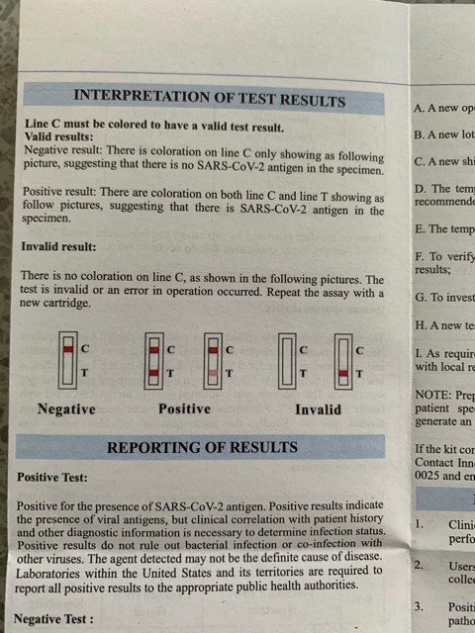

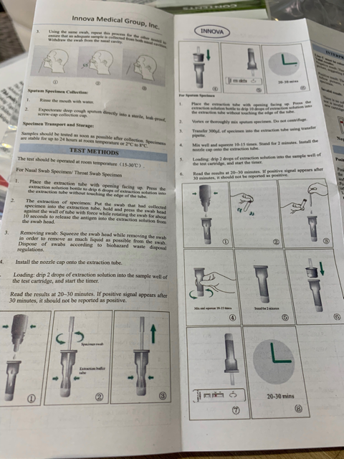
More information on managing risk: www.hse.gov.uk/simple-health-safety/risk/

Published by the Health and Safety Executive 10/19

